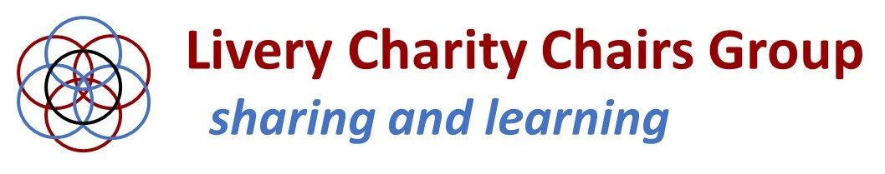

Livery Charity Chairs and Trustees - and Company Masters and Clerks
who may well be involved in aspects of their Charity - are invited to our:
2023 Annual Conference
to be held at Ironmongers’ Hall, EC2Y 8AA, on Tuesday 13th June from 13:30 – 19:00
Tickets: £65 per delegate
Application Form
You can send in as many Application Forms as you wish for each Charity/Company.
There is a limit on available places, so early booking is encouraged.

Name of Livery Company: ………………………………………………………………………

Details of those attending:

Name E-mail address Office in Charity/Company

………………………………. ……………………………… ..……………………………
………………………………. ……………………………… .…………………………….
………………………………. ……………………………… ……………………………..
………………………………. ……………………………… …………………………….

I wish to apply for ........ ticket(s) for this event @ £65.00 each

Either
I have remitted the sum of £................... in settlement of ......... tickets @ £65.00 each to The Chartered Accountants Livery Charity RBS bank account number 23170690, sort code 16-00-15.

Please use ‘LCCG’ followed by the first delegate’s surname as your payment reference
Payment was made on ............................................................ (date)
using the reference .................................................................................
Or
I enclose my cheque for £................... in settlement of ......... ticket(s) @ £65.00 each,
made payable to “Chartered Accountants’ Livery Charity”

Signed …………………………………………………….. Name ……………………………………………………
Please send your completed form by email to liverycharitychairsgroup@gmail.com or by post to
Dr Hilary Lindsay, Chartered Accountants’ Livery Charity, 23 Stourhead Drive, Northampton, NN4 0UH.
NB Closing date for receipt of booking forms and payments: Monday 5th June 2023
For queries, please contact LCCG Convenor Hilary Lindsay (liverycharitychairsgroup@gmail.com).

